Assignment 8 JDBC Connectivity

Inserting Records :

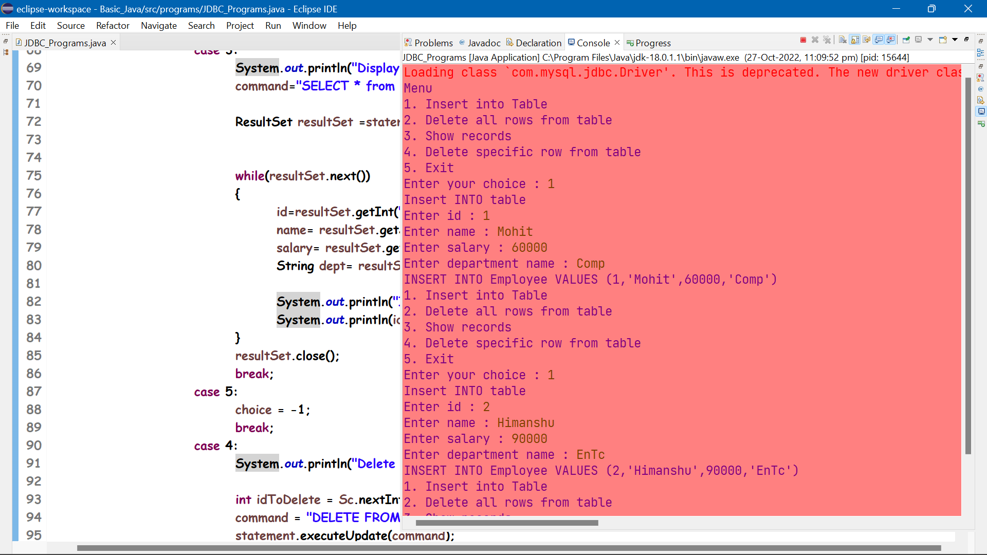

Display In Command Prompt :

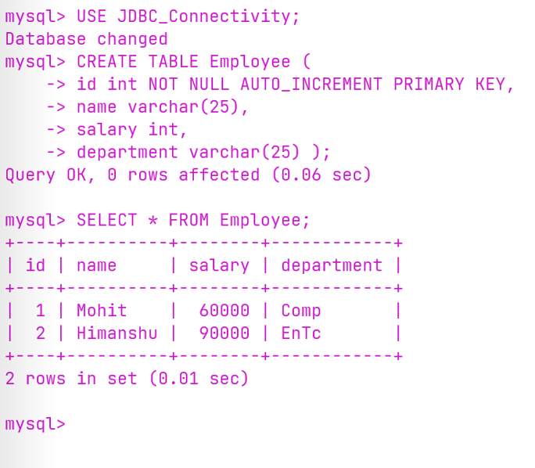

Displaying in Console through JDBC :

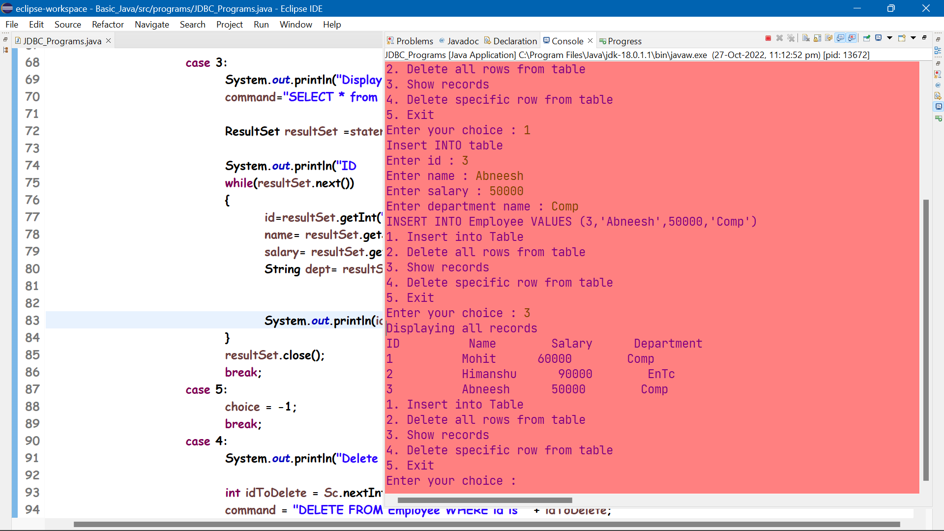

**Deleting a specific row through Java Program**

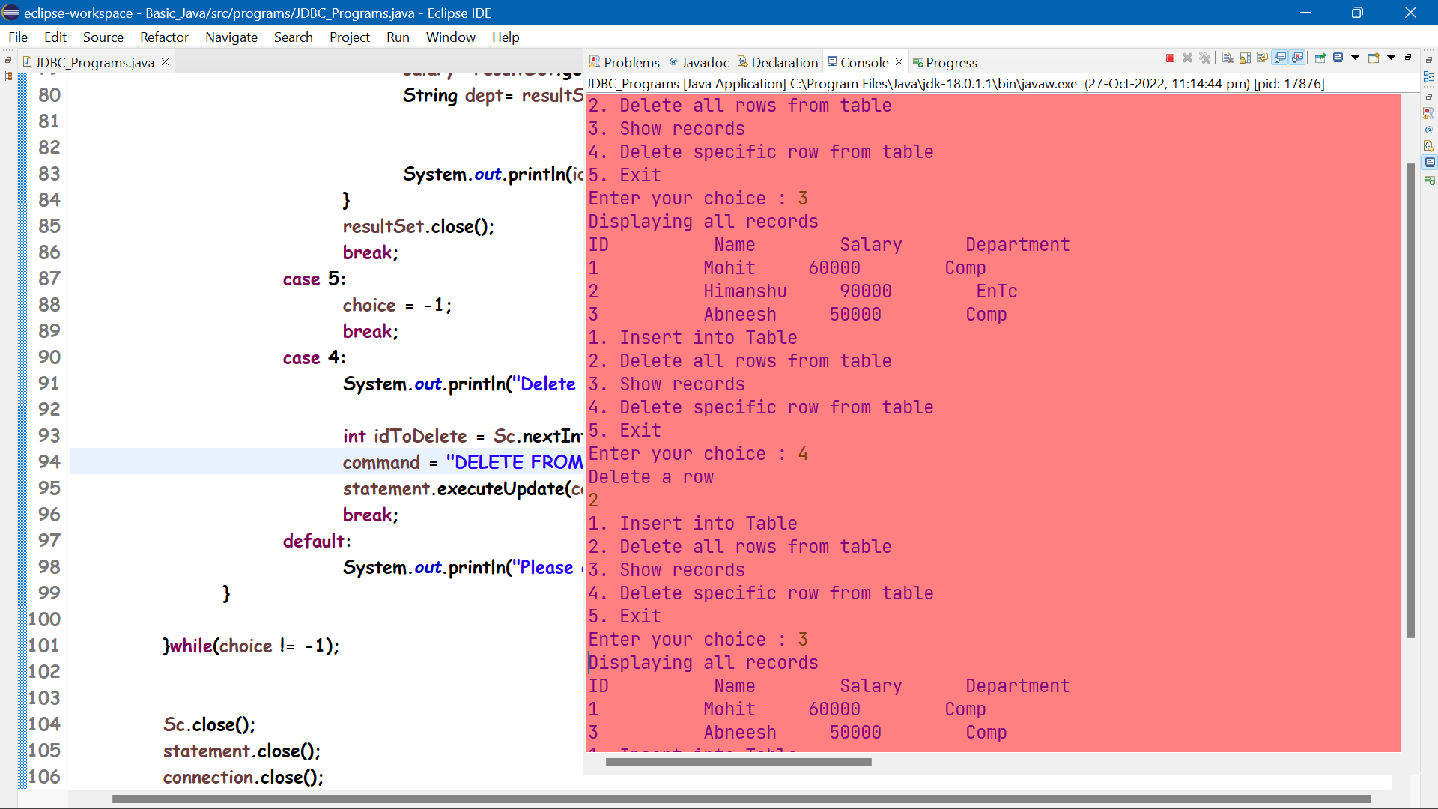

**Displaying in Command Prompt**

